Contribution Title.

Nombre del autor

*Universidad Politécnica Salesiana, (Ecuador)*

Orcid: <https://orcid.org/> XXXX-XXXX-XXXX-XXXX

Nombre del autor

*Universidad Politécnica Salesiana, (Ecuador)*

Orcid: https:// orcid.org/ XXXX-XXXX-XXXX-XXXX

Nombre del autor

*Universidad Politécnica Salesiana, (Ecuador)*

Orcid : https:// orcid.org/XXXX-XXXX-XXXX-XXXX

# INTRODUCTION

In Ecuador, cocoa is a very important crop, both economically and culturally. How-ever, the presence of heavy metals such as cadmium (Cd) in the soil and in cocoa plants raises significant concerns. Studies have shown that Ecuadorian agricultural soils are contaminated by cadmium, with concentrations that can affect cocoa quality (Pernía et al., 2021).

Cadmium uptake in cocoa is influenced by the diversity of arbuscular mycorrhizal fungi present in the soil, which in turn affects plant growth (Vallejos-Torres et al., 2021). The high concentration of Cd in cocoa beans has raised concerns among Ecuadorian producers who export to international markets (Unda et al., 2021).

It is crucial to understand how Cd affects cocoa quality and safety, considering that Ecuador is recognized for its fine aroma cocoa worldwide (Villacis et al., 2022). The genetic diversity of cocoa in Ecuador, especially the “Nacional” or “Arriba” variety, is an important asset in the cocoa value chain in the country (Villacis et al., 2022).

The sustainability of cocoa agroforestry systems in Ecuador is also influenced by factors such as management intensity and the diversity of non-vascular epiphytes in cocoa plantations (Andersson & Gradstein, 2005; Neira, 2016). The genetic variability of cacao populations in Ecuador has been studied using genetic markers, which has revealed interesting patterns of genetic diversity (Nieves‐Orduña et al., 2021). The genetic diversity of cocoa in Ecuador, including ancestral varieties such as Criollo, is favored by the presence of mycorrhizae, which helps to conserve valuable genetic material and improve cocoa quality in new varieties (Solorzano et al., 2009).

Mycorrhizae are key to cocoa crops in Ecuador by improving nutrient and water uptake by cocoa plants. These symbiotic associations between plant roots and arbus-cular mycorrhizal fungi are essential for the optimal development of cocoa plants, especially in soils degraded or contaminated by heavy metals such as Cd (Tezara et al., 2016).

The presence of a high diversity of arbuscular mycorrhizal fungi in the soil can positively influence Cd uptake and plant growth of cocoa, which contributes to mitigate the negative effects of heavy metal contamination (Zug et al., 2019).

The quality of cocoa cultivation in Ecuador benefits from the presence of mycorrhizae, as these associations improve plant resistance to diseases and environmental stresses, which in turn contributes to the production of high-quality cocoa appreciated worldwide for its distinctive organoleptic characteristics. In a context where Cd contamination in cocoa crops is a growing concern, mycorrhizae play a crucial role in influencing the uptake and mobilization of this heavy metal in cocoa plants. Studies have shown that the presence of mycorrhizae can re-duce cadmium accumulation in cocoa beans, which is critical to ensure food safety and quality of cocoa produced in Ecuador (Zug et al., 2019).

Therefore, the objective of this research is to evaluate the impact of arbuscular mycorrhizal symbiosis on the attenuation of Cd uptake in T. cacao L. seedlings grown under greenhouse conditions.

# MATERIALS AND METHODS

**Plant material:** Grafted seedlings of national cocoa from the National Institute of Agricultural Research (INIAP) located at Km. 26 Vía Duran -Tambo, Virgen de Fátima parish, Yaguachi canton in the province of Guayas were used.

**Experimental design:** A completely randomized experimental design with interaction was implemented to evaluate the effect of Cd on the growth and physiology of plants of T. cacao L. The design included four levels of Cd (0, 2, 4 and 6 mg/kg) with six replicates per level. The response variables evaluated were: plant height, number of leaves, aerial biomass, root biomass, soil pH, soil electrical conductivity and quantification of Cd uptake.

DCA=γ=μ+δ+ε

**Sample Preparation & Analysis**

Seedlings were transplanted into a substrate composed of chaff and sand in a 1:1 (v/v) ratio, which had an electrical conductivity of 0.561 dS m-1 and a pH of 6.90. After establishment of the trials, the plants were irrigated for two weeks with a modified Steiner's nutrient solution and water, which contained 0, 2, 4 and 6 ppm cadmium nitrate (Cd(NO3)2). The substrate was maintained at field capacity by applying 70 ml of the above solutions three times per week.

**Evaluation of agronomic parameters**

To evaluate both root and aerial biomass, roots are washed with distilled water and dried in an oven at 80°C for 24 hours or until constant weight, recording the dry weight as root biomass (g/plant). In the case of aerial biomass, stem and leaves are separated, weighed on an analytical balance (wet weight) and dried in an oven at 80°C for 24 hours or until constant weight, recording the dry weight as aerial biomass (g/plant).

Biomasa (g/planta) = Peso húmedo inicial (g/planta) - Peso seco final (g/planta)

**Separation of spores and identification of abuscular mycorrhizae**

To separate arbuscular mycorrhizal spores according to the methodology of wet sieving and decantation of spores by their density (Furlán et al., 1980), the sediment from the 45 um sieve is dissolved in water with tween 20 and 50% sucrose for 5 minutes at 3000 rpm in a centrifuge, 1980), the sieve sediment 45 um dissolved in water with tween 20 and 50% sucrose for 5 minutes at 3000 rpm in a centrifuge, collected in a 50 ml falcon tube, and then characterized the spores at the taxonomic level using morphological catalogs of spores obtained from INVAM, according to the morphological attributes of the spores present, such as color, shape, texture, size, mucilage, walls, presence of ornamentation.

**Root staining:** At the end of the experiment, roots were extracted from seedlings to analyze the presence of fungal structures (hyphae, vesicles or arbuscules), a method modified by Phillips and Hayman (1970). Secondary roots were immersed in 10% potassium hydroxide for the first decolorization, then the second decolorization with 3-4% hydrogen peroxide for 24 hours, followed by washing and immersion with 1% hydrochloric acid and staining with trypan blue in 0.02% lactic acid. Finally, they were observed under the microscope (40x objective) to evaluate the percentage of mycorrhizal colonization, using 10 rootlets per objec-to plate and fixed with lactoglycerol (lactic acid, glycerol, distilled water in a 1:1:1 ratio), to demonstrate mycorrhizal colonization.

**Determination of cadmium:** For quantification of Cd concentrations, approximately 0.25 g of soil, 0.5 g of roots and 1 g of leaves were weighed, 7 ml of nitric acid and 3 ml of hydrogen peroxide were added, and the samples were placed in Milleston Connect microwave beakers. Ramp heating was performed to 180°C for 10 min, the temperature was held constant for 15 min, and finally the samples were allowed to cool for an additional 15 min. Samples were transferred to 25-ml volumetric flasks, volumetrically diluted with HPLC water, and filtered with 22 μm syringes and microfilters prior to analysis by graphite furnace atomic absorption spectrophotometry (Table 1). A total of 96 samples were analyzed

Table 1. Instrumental conditions of Graphite Furnace Atomic Absorption Spectrometry (GFAAS).

|  |  |
| --- | --- |
| Wavelength | 228.80 nm |
| Calibration curve | 0.25 ug/L |
| 0.50 ug/L |
| 1.0 ug/L |
| 2.0 ug/L |
| 5.0 ug/L |
| Fuel | Argon |
| Matrix Modifier | 0.015 mg Pd + 0.01 mg Mg (NO3)2 |
| Background Corrector | On |

In this study, the limit of detection (LOD) of 0.006 mg/kg was established based on the variability of the blank samples, calculated as three times the standard deviation of the average blank concentration value. To determine the limit of detection (LOQ), samples with known low concentrations of cadmium were analyzed in triplicate, resulting in 0.1 mg/kg. Finally, the coefficient of correlation (R2) was established with a value of 0.998811 following the methodology established by the EPA-3051A method.

Data analysis

Data processing and analysis were performed using RStudio software version 4.3.2 (2023-10-31 ucrt). Means and standard deviations were calculated for all measured variables, including cadmium solution in soil, cadmium concentration in roots and leaves of seedlings, bioconcentration factor (BCF), translocation factor (TF), soil pH, electrical conductivity, aerial and root biomass, number of leaves and height of seedlings. Scatterplot matrices with least squares lines were constructed to visualize the relationship between the different variables measured. The least squares lines allowed identifying linear patterns and estimating the slope of the relationship between the variables. Concentration ellipsoids were generated with a 90% confidence level for each variable, which made it possible to identify the regions of greatest data concentration.

RESULTS

Figure 1 explores the relationship between cadmium (Cd) concentration in the soil and several growth variables in cocoa seedlings inoculated with arbuscular mycorrhizal fungi. The data presented are from measurements taken at different Cd concentrations, represented by the dots in the graph. The distribution of the data for each growth variable at each Cd concentration is visualized by box plots, while the concentration ellipsoids represent the joint variability of the growth variables at each Cd level. The results reveal a positive correlation between Cd concentrations and the growth variables analyzed. This correlation is evident in seedling height, where the 6 mg/kg Cd concentration induces a maximum growth of 9.50 cm, significantly higher than that of the control group. In addition, this Cd concentration generates a considerable increase in the number of leaves. These findings suggest that, within the range of Cd concentrations used in this study, no adverse effects on the growth variables evaluated are observed. In this range, aerial and root biomass reached values of 13.91 g and 6.91 g, respectively, showing a tendency to gradually increase as Cd concentration increases.

Figure. 1 Effect of Cd concentration on seedling height, aerial biomass, root biomass and number of leaves of cocoa seedlings with arbuscular mycorrhizae. Scatter plots show the relationship between the response variable.

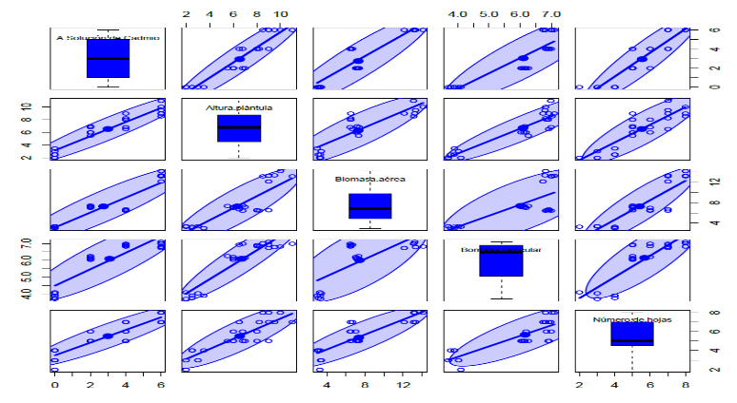

Figure 2 presents a scatterplot matrix with box plots and concentration ellipsoids to examine the relationship between cadmium (Cd) concentration in soil and its content in different plant parts (root, leaves), as well as BCF, TF, pH and electrical conductivity in cocoa seedlings inoculated with arbuscular mycorrhizal fungi. The results reveal a positive relationship between Cd concentrations in the soil and its content in different parts of the plant (root, leaves), BCF and electrical conductivity. This correlation is evidenced by a gradual increase in these variables as soil Cd concentration increases. The BCF of 2.67 ± 0.10 indicates a high potential of the plant to accumulate Cd in its leaves and roots, which is corroborated by the strong correlations observed between Cd in the soil and its content in the aerial parts. However, an inverse relationship was observed between Cd concentrations and TF, which means that the higher the concentration of Cd in the soil, roots and leaves, the less Cd is transferred to the aerial parts. The FT in this study was 0.7 ± 0.01. It is important to highlight the strong correlation between electrical conductivity and the presence of Cd in the soil, roots and leaves, with a maximum electrical conductivity value of 94.11 µS/cm. For the pH range studied, a significant correlation was observed with the Cd content. However, it is suggested to widen the pH range in future research, since cocoa growing soils tend to be more acidic.

Figure. 2 Effect of cadmium application at different concentrations (0, 2, 4 and 6 mg/kg) on cadmium content in soil, root, leaves, FBC, FT, pH and electrical conductivity in cocoa seedlings with

As a result of spore identification, ten genera were obtained in all the evaluated samples of arbuscular mycorrhizae in symbiosis with cocoa seedlings, the most representative genera were *Acaulospora* and *Entrosphospora* as shown in Fig. 3. The morphological observation of spores shows that they benefit plant growth and production. In particular, its ability to absorb soil nutrients, phosphorus and water. It was found that cocoa seedlings were 100% colonized in all treatments and typical fungal structures of arbuscular mycorrhizae such as intra and extraradices hyphae, vesicles and arbuscules were observed (Fig. 4). This shows that mycorrhizae have a significant contribution in the phytostabilization of Cd in the rhizosphere of cocoa plants.

Figure. 4 . Mycorrhizal colonization of the roots of cocoa seedlings (*Theobroma cacao L.)*.

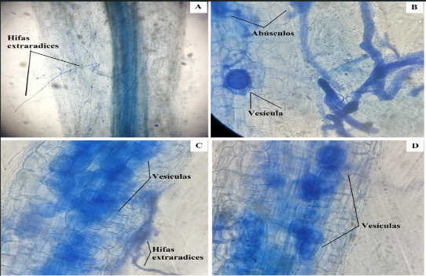

DISCUSSIONS

The results presented in Figure 1 provide valuable information on the tolerance of cocoa seedlings inoculated with arbuscular mycorrhizae to Cd exposure in soil. The absence of negative effects on growth variables, and even the observation of enhanced growth at some Cd concentrations, suggests that arbuscular mycorrhizal symbiosis could play a protective role in the response of cocoa seedlings to Cd stress. This hypothesis is based on the ability of arbuscular mycorrhizae to enhance nutrient and water uptake by plants, which could compensate for the adverse effects of Cd and, in some cases, even stimulate growth (Tezara et al., 2016). The findings presented in Figure 2 provide information on the distribution and behavior of Cd in cocoa seedlings inoculated with arbuscular mycorrhizal fungi. The gradual accumulation of Cd in the plant parts as its concentration in the soil increases suggests that Cd uptake and retention mechanisms are not significantly affected by arbuscular mycorrhizal symbiosis. The high BCF indicates that cocoa has a high capacity to concentrate Cd, which could pose a risk to human health if this metal is transferred to the edible parts of the plant. However, the relatively low TF suggests that the arbuscular mycorrhizal symbiosis could be contributing to limit the transfer of Cd to the aerial parts, which could reduce the risk of contamination in the cocoa bean. The strong correlation between electrical conductivity and the presence of Cd in soil, root and leaves suggests that soil salinity could be influencing Cd availability and uptake by the plant. The significant relationship between pH and Cd content within the range studied indicates that soil acidity could affect Cd bioavailability. However, further studies are needed to explore this phenomenon in a wider pH range, representative of cocoa growing conditions.

Similar results have further explored the mechanisms of metal transfer from soil to grain, which is crucial for understanding bioaccumulation Galvis (2023).

# CONCLUSIONS.

The cadmium concentrations evaluated in this study did not negatively affect the growth of cocoa seedlings. In this context, arbuscular mycorrhizae are chosen as key allies to mitigate this risk. By colonizing 100% of the seedling roots, these fungi promote the phytostabilization of cadmium in the rhizosphere. This plant-mycorrhizal fungus symbiosis is presented as a promising strategy to reduce soil contamination by this heavy metal, thus protecting human health and the environment.

# REFERENCES

1. Andersson, M. and Gradstein, S. (2005). Impact of management intensity on non-vascular epiphyte diversity in cacao plantations in western ecuador. Biodiversity and Conservation, 14(5), 1101-1120. https://doi.org/10.1007/s10531-004-7840-5
2. Bisht, A., & Garg, N. (2024). Harnessing the role of arbuscular mycorrhizae in arresting nodular senescence by modulating osmolyte synthesis and ascorbate-glutathione pool in cadmium stressed pigeon pea. Plant Growth Regulation, 102(2), 409-427.
3. Blommaert, H., Aucour, A., Wiggenhauser, M., Moens, C., Télouk, P., Campillo, S., … & Sarret, G. (2022). From soil to cacao bean: unravelling the pathways of cadmium translocation in a high cd accumulating cultivar of theobroma cacao l. Frontiers in Plant Science, 13. <https://doi.org/10.3389/fpls.2022.1055912>